Project Design Phase-II
Data Flow Diagram & User Stories

Date | 26-05-2025
Team ID
Project Name | StaffSync
Maximum Marks | 4 Marks

Data Flow Diagrams:
The Data Flow Diagram illustrates how different types of users (HR, Manager, and Employee) interact with the HRM System from login to completing their specific tasks. It visually represents the flow of actions within the application to ensure smooth and logical navigation for every role.
Example: DFD Level 0 and Core Processes

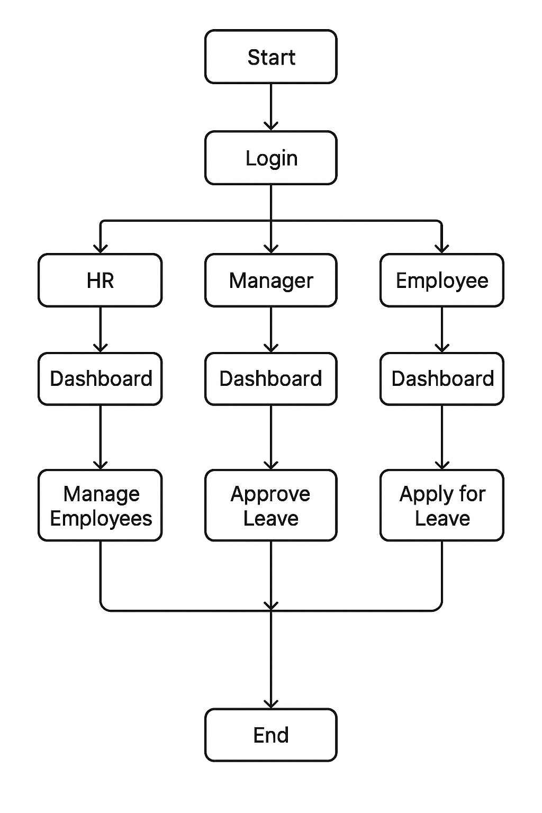

User Stories

User Story Table – StaffSync
User Type | Functional Requirement (Epic) | User Story / Task | Acceptance Criteria | Priority | Release
HR Personnel |  | As an HR personnel, I want to add, update, and archive employee records, so that the organizational directory remains accurate. | The employee profile is successfully created in MongoDB and displays correct details on the dashboard . | High | Sprint-1
  Employee Management
HR Personnel |  | As an HR personnel, I want to view daily attendance logs across all departments, so that I can monitor punctuality and presence. | Attendance table reflects real-time punch-in/out records filtered by date and department. | High | Sprint-1
  Attendance Tracking
Manager | Leave Management |  | Status updates immediately (Approved/Rejected) and an email/system notification is triggered to the employee. | High | Sprint-2
  As a manager, I want to review and approve or reject leave requests submitted by my team members, so that team availability is maintained.
Employee | Leave Application | As an employee, I want to apply for leaves specifying dates and reasons, so that I can request time off seamlessly. | Leave request is successfully submitted and appears under the pending requests tab with remaining balance. | High | Sprint-2
Manager | Training & Development | As a manager, I want to assign and track training programs for my team members, so that I can foster skill growth. . | Training modules and progress status are accurately listed under the employee development dashboard. | Medium | Sprint-3
HR Personnel | Announcements & News | As an HR personnel, I want to post company-wide announcements, so that all employees stay updated with important notices. | Published announcement instantly appears on the home dashboard feed for all logged-in user roles. | Medium | Sprint-3

